Advanced Prostate Cancer or “Castrate Resistant Prostate Cancer”- This is the stage of prostate cancer when some of your prostate cancer cells have stopped responding to hormonal therapy as indicated by a rising PSA level. During this stage men may have new complaints of pain, fatigue, or an increase in urinary symptoms. Imaging scans are needed to determine whether the cancer has spread to other parts of the body. Additional treatment is required to help slow the cancer’s growth. However, hormone injections are still need as this medication is still effective in treating some of the prostate cancer cells.

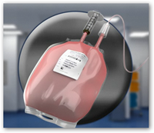Provenge (Sipuleucel-T) is Immunotherapy to treat prostate cancer. Your own immune cells are removed, modified and re-infused into your body to fight your cancer. There are 6 total appointments, broken into three cycles that include: An appointment for blood cell removal at the Red Cross in Omaha (Leukapheresis) followed 3 days later by an appointment for cell re-infusion at our office. This can be completed in 5-6 weeks. A special type of IV catheter may be need to be placed for the duration of this therapy.

Oral medications- Two oral medications are available that assist with treatment of prostate cancer. Xtandi (enzalutamide) and Zytiga (abiraterone acetate). These medications act in slightly different ways to prevent prostate cancer cells from growing and spreading. One medication may be more appropriate for you than another based on your particular medical history. They are very expensive medications, but assistance may be available from cancer foundations. Additional information will be provided about administration if your medical provider prescribes this for you. A common side effect is fatigue.

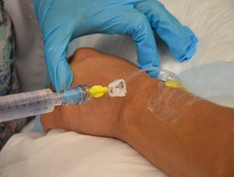Xofigo (Radium 223) is a once a month injection (given for 6 months) used to help with pain and symptoms associated with metastatic disease (for cancer that has spread to your bones). This will have little to no effect on PSA level but has shown in clinical trial to improve survival, and may help with discomfort. This IV injection takes about 15 minutes to administer, and is given by a nuclear medicine physician, here in our facility. The most common side effect is diarrhea, lasting 1-2 days.

Palliative Care is an option where you elect to receive minimal cancer therapy and allow the disease to slowly progress. Treatments or medications would be to treat pain or other side effects of the cancer. Your provider may refer you to a hospice organization as needed.

